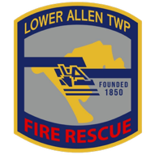

FIRE CHIEF RECRUITMENT
Candidate Supplemental Questions

To give Lower Allen Township a better sense of your communication skills and experience, please answer the following questions and include your name. Please limit each response to 1 paragraph, with both responses combined not to exceed 1 page total.

NAME:

1) Combination Fire Service Leadership
Describe your experience leading a combination fire service and how you have successfully built trust and unity between career and volunteer personnel.

2) Organizational Leadership
Describe an organization you helped move forward by establishing clearer structure, expectations, and accountability. What was your role and what resulted?

