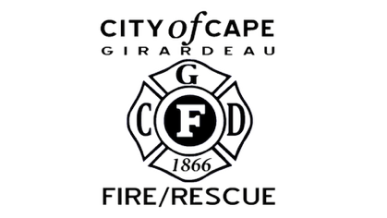

DEPUTY FIRE CHIEF RECRUITMENT
Candidate Supplemental Questions
To give the Cape Girardeau Fire Department a better sense of your experience, please answer the following questions and include your name. Please limit each response to 1 paragraph, with both responses combined not to exceed 1 page total.
NAME:

1) Leadership & Accountability
Describe your approach to building accountability and developing future leaders within a young or transitioning workforce.
2) Operational & Organizational Improvement
Describe an operational or organizational improvement you led, including your role and the results achieved.

