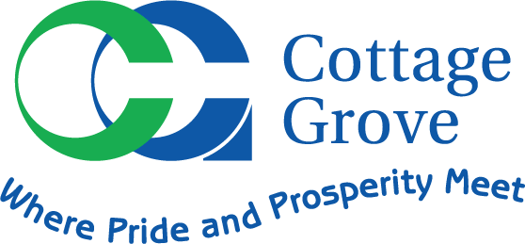

UTILITIES SUPERINTENDENT RECRUITMENT
Candidate Supplemental Questions

To give the City of Cottage Grove a better sense of your communication skills and experience, please answer the following questions.

1) Do you have a bachelor's degree in public administration, public works, engineering or related field?

2) Do you have at least five years progressive experience in field related to Public Works or Infrastructure Management?

3) Do you have two years supervisory experience?

4) Are you a Veteran, or the surviving spouse of a deceased Veteran, that has been issued a DD214 form?

5) Are you a disabled Veteran as determined by the United States Veterans Administration? Or, are you the spouse of a disabled Veteran who because of the disability is unable to qualify for this position?

6) Summarize your management style.

7) Discuss your experience in project management. How does it differ from internal work crews to contracted services?

8) Describe your experience with Asset Management and overseeing the capital and operation and maintenance activities of municipal utilities.

9) Describe your experience with construction plan reviews.

